BLOCKCHAIN MINI PROJECT
Title of Mini Project: A blockchain-based supply-chain system to detect and prevent fake products using QR-linked provenance and Sepolia ETH payments.
Group Members of Mini Project:
1. Atharva Harane - 15
2. Darsh Kamble - 23
3. Altamash Chougle - 05

Theory:

Problem statement:

Counterfeit goods cause financial loss, brand damage, and safety risks. Current centralized supply-chain records are easily altered or forged, making it hard for consumers and downstream partners to verify a product’s authenticity and full provenance.

Concept / Overview:

Use a public blockchain as an immutable ledger to record product lifecycle events (manufacture → supplier → retailer). Each manufactured item is assigned a unique serial number and a public QR code that links to its on-chain record. Role-based actors (manufacturer, supplier, retailer) update product state and pay small transaction fees (Sepolia test ETH in development) via a connected wallet (MetaMask). An admin manages user accounts in the web app. The QR code lets any participant or consumer fetch the canonical history and verify authenticity.

Key features:

Immutable provenance: Every state change (creation, transfer, update) is recorded on-chain so history cannot be silently altered.

Role-based workflows: Admin, Manufacturer, Supplier, Retailer each have defined permissions (create, update, verify).

QR code issuance: After on-chain registration, a QR (containing contract address + serial) is generated and published for scanning.

Wallet-based payment & signing: Actors pay transaction gas and sign actions with their wallets (MetaMask).

Off-chain metadata + on-chain anchor: Detailed product data (images, descriptions, location) stored off-chain (or IPFS) and anchored on-chain via hashes to save cost.

Public verifiability: Anyone scanning the QR can query the contract to validate the canonical record.

Audit trail & timestamps: On-chain timestamps provide tamper-proof time ordering for all events.

Flowchart:

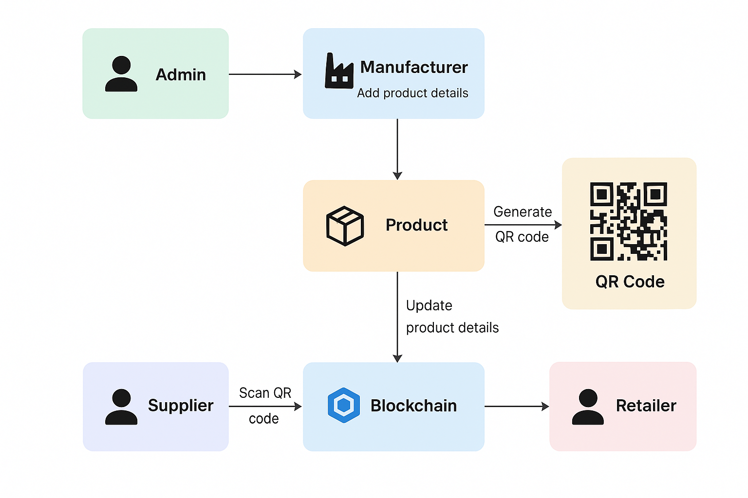

Applications:

Luxury goods anti-counterfeiting: Handbags, watches, jewellery.

Pharmaceutical supply-chain: Track batches and expiry to prevent fake/expired medicines.

Electronics and spare parts: Validate origin of components.

Food provenance: Verify farm-to-shelf history for high-value or regulated foods.

Use Case:

Admin — manages web app accounts (create manufacturer/supplier/retailer).

Manufacturer — creates a product record in the web UI (name, image, description, location, manufacture date). The dApp:

uploads image/metadata off-chain (or to IPFS),

calls contract to register product (serial number, metadata hash),

pays Sepolia ETH via MetaMask, and

receives a public QR code (contract address + serial) to attach to the item.

Supplier — scans QR, fetches canonical data, updates shipment/receiving events on-chain (signed & paid via wallet).

Retailer — scans QR on receipt or at point-of-sale to confirm authenticity and update sale or shelf status.

Consumer/Verifier — scans QR and reads the complete on-chain provenance to confirm authenticity and ownership history.

Advantages:

Tamper resistance — record immutability discourages and detects fraud.

Transparency — easy public verification without trusting a single central authority.

Accountability — every actor’s actions are signed by their wallet address.

Interoperability — standard contract interfaces let other services integrate verification.

Limitations & considerations:

Gas costs & UX: On-chain transactions cost gas — use test net (Sepolia) for development and consider batching or Layer-2/main net optimizations for production.

Off-chain data integrity: Store large data off-chain (IPFS/S3) and anchor cryptographic hashes on-chain to prevent tampering while keeping costs low.

Privacy: Public on-chain data is transparent—avoid storing sensitive PII on-chain; store only hashes or encrypted payloads off-chain.

Key management: Actors must securely manage wallet keys (MetaMask). Lost keys = loss of ability to sign updates.

Trust bootstrapping: The system’s effectiveness improves with ecosystem adoption—brands and partners must participate.

Output:

1.1 Landing Page
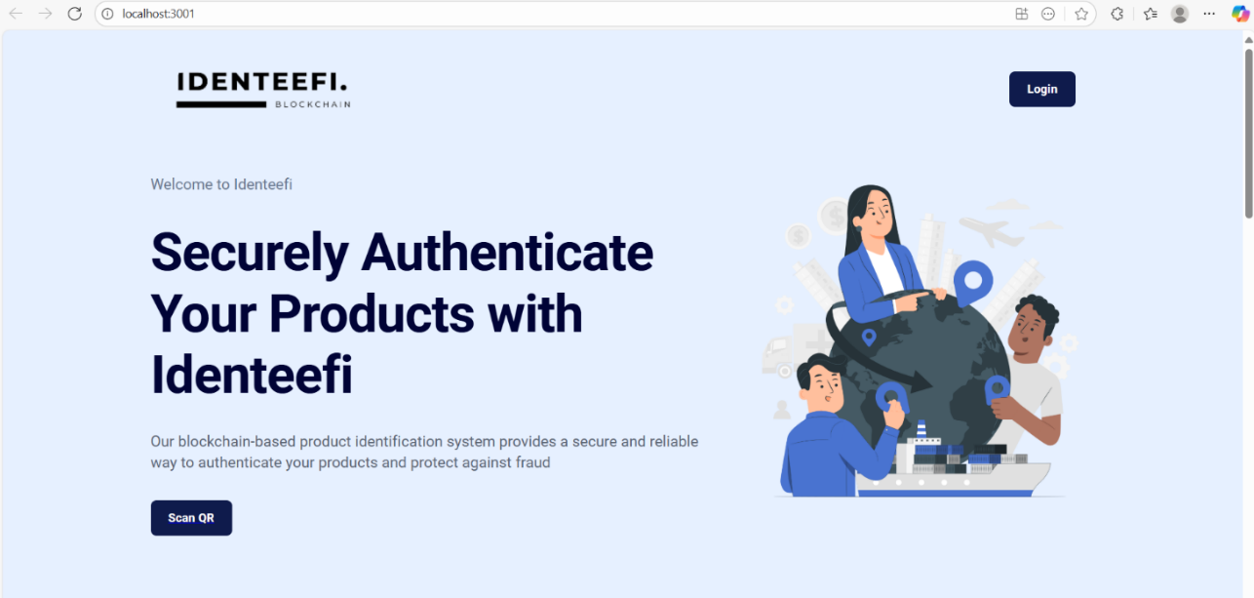

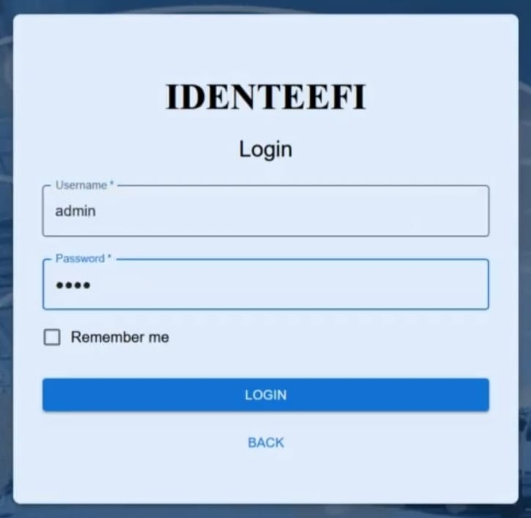
1.2 Login Page
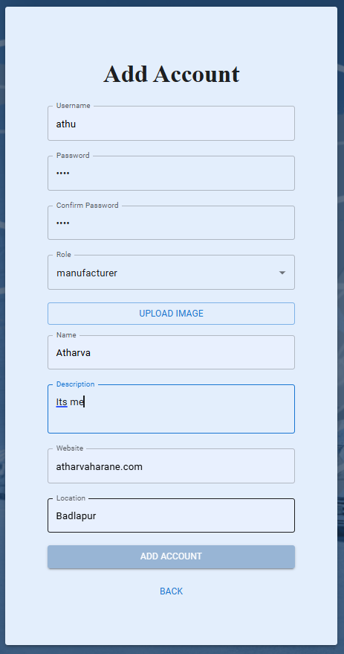
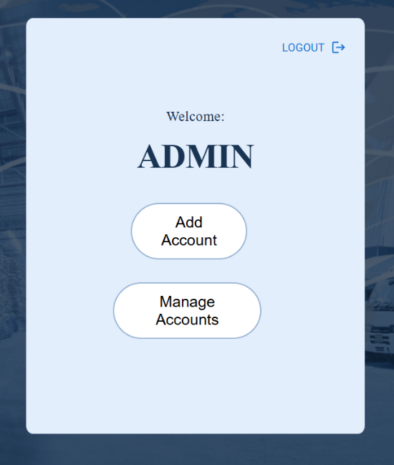
1.2.1 Add Account by Admin

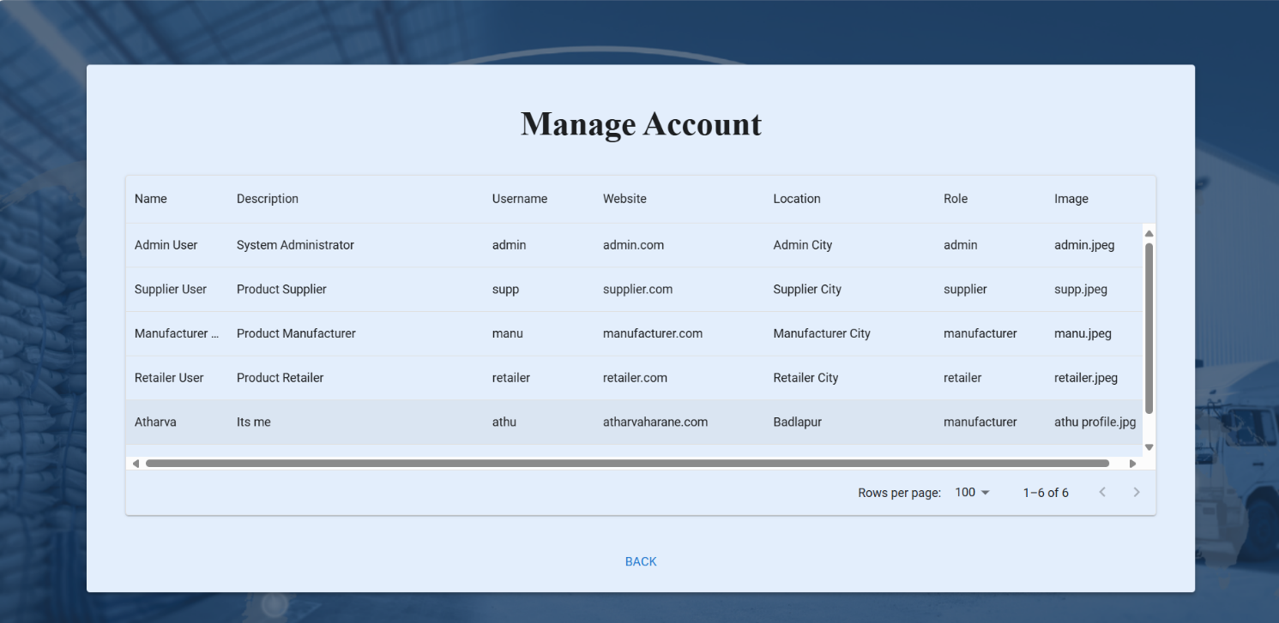
1.2.2 Manage Accounts by Admin

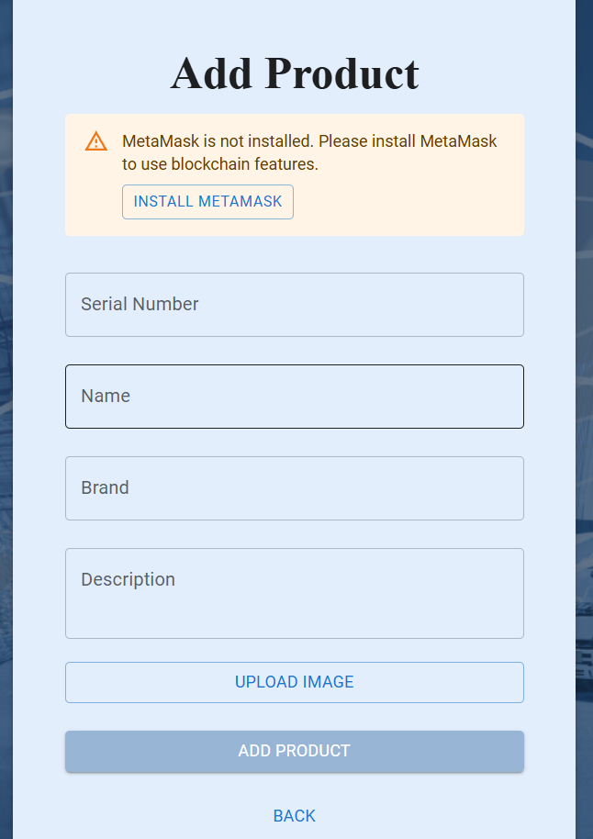
1.3.1 Add New Product by Manufacturer
1.3.2 Registering Product on Blockchain by Manufacturer

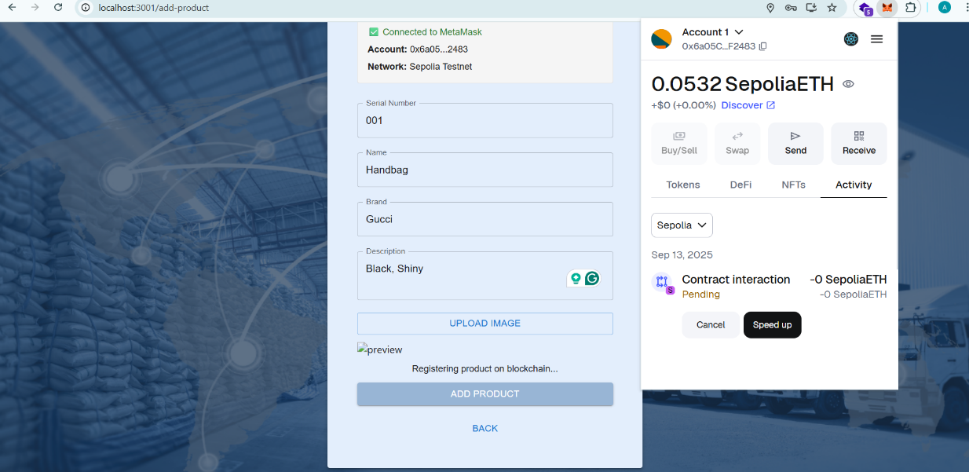
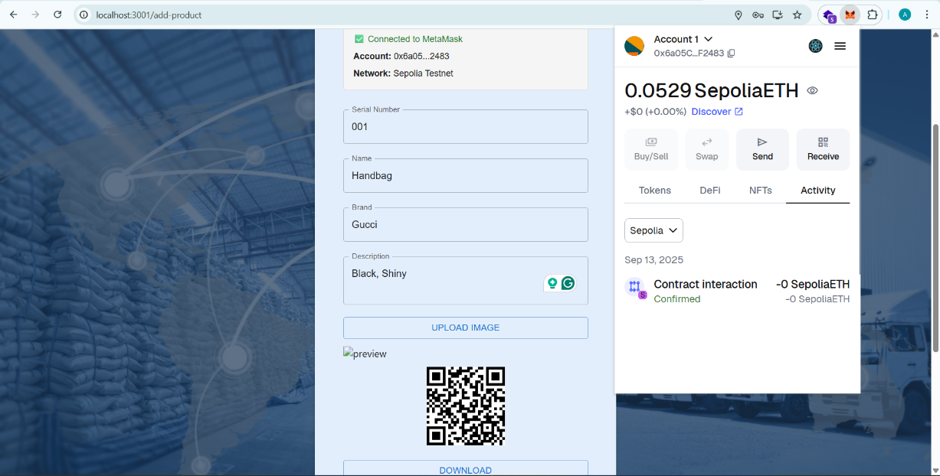
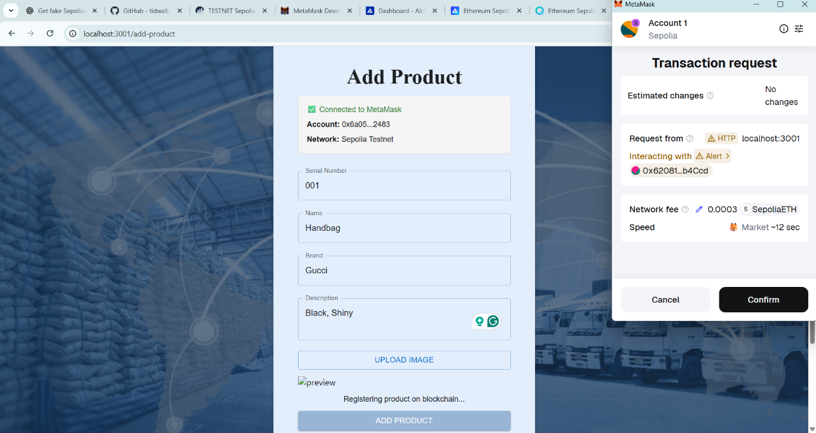

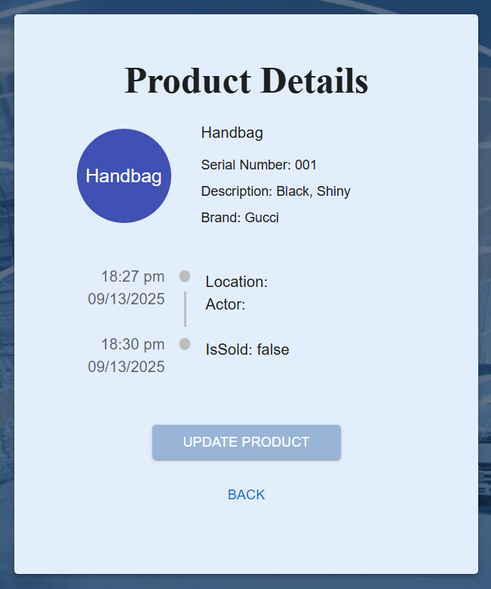
1.4.1 Supplier can get Product Details

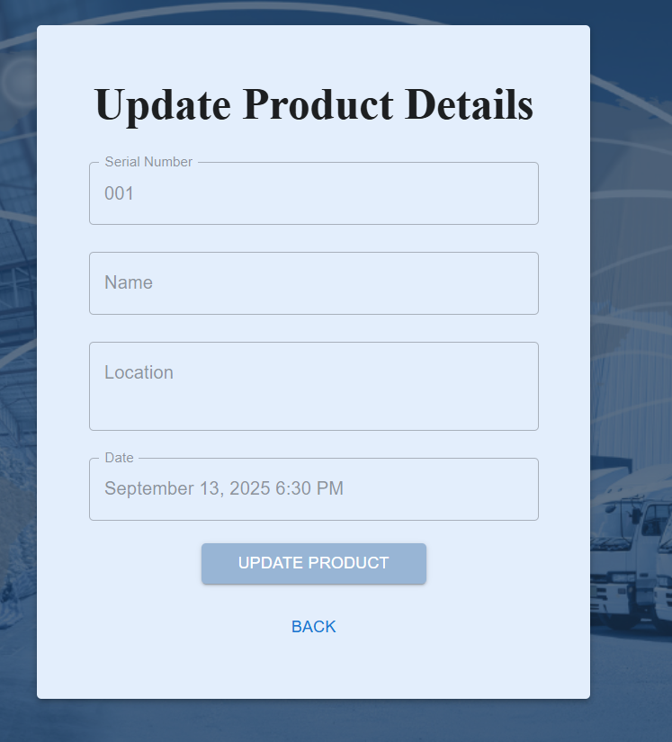
1.4.2 Supplier can Update the Product Details

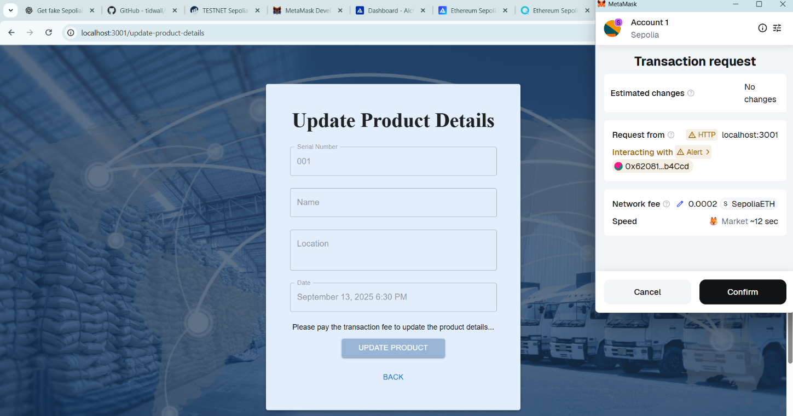

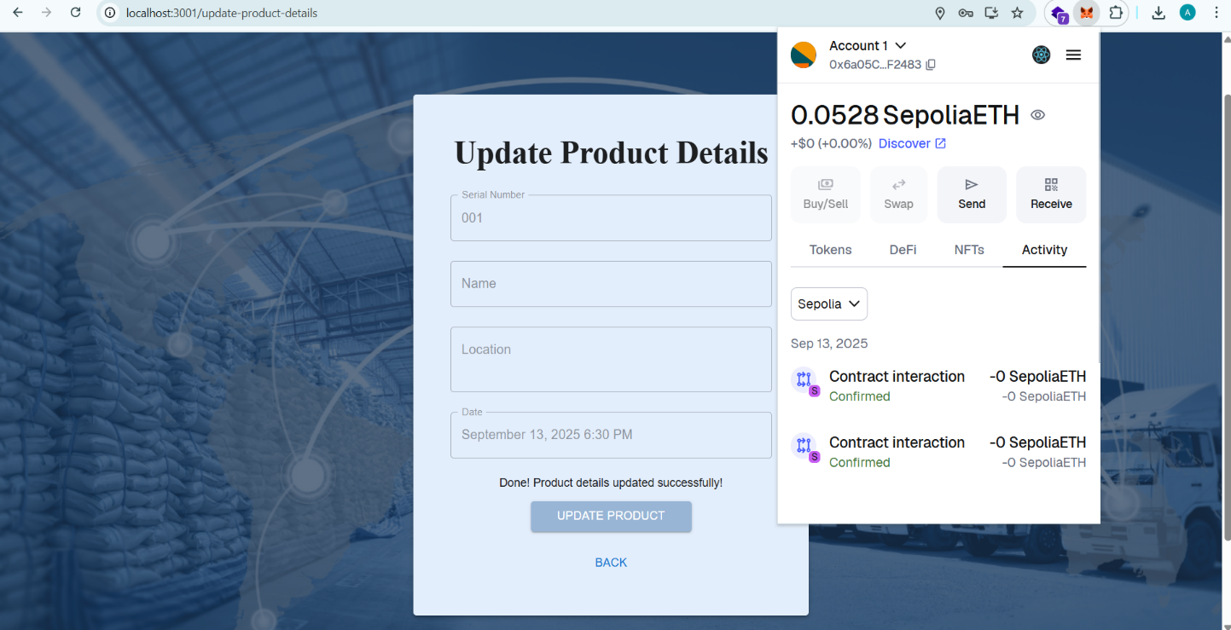

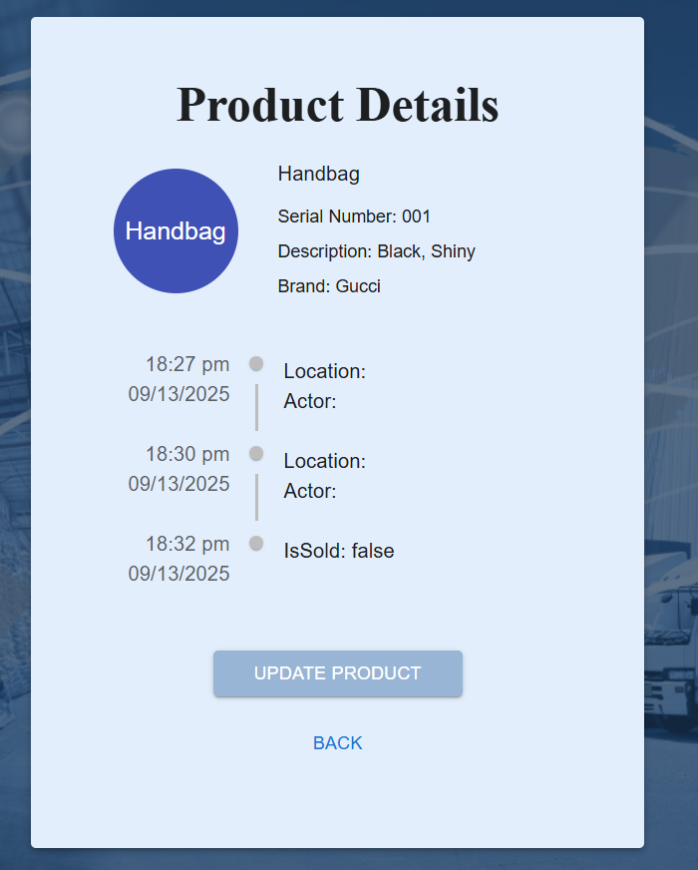
1.5 Supplier can see the Updated Product Details

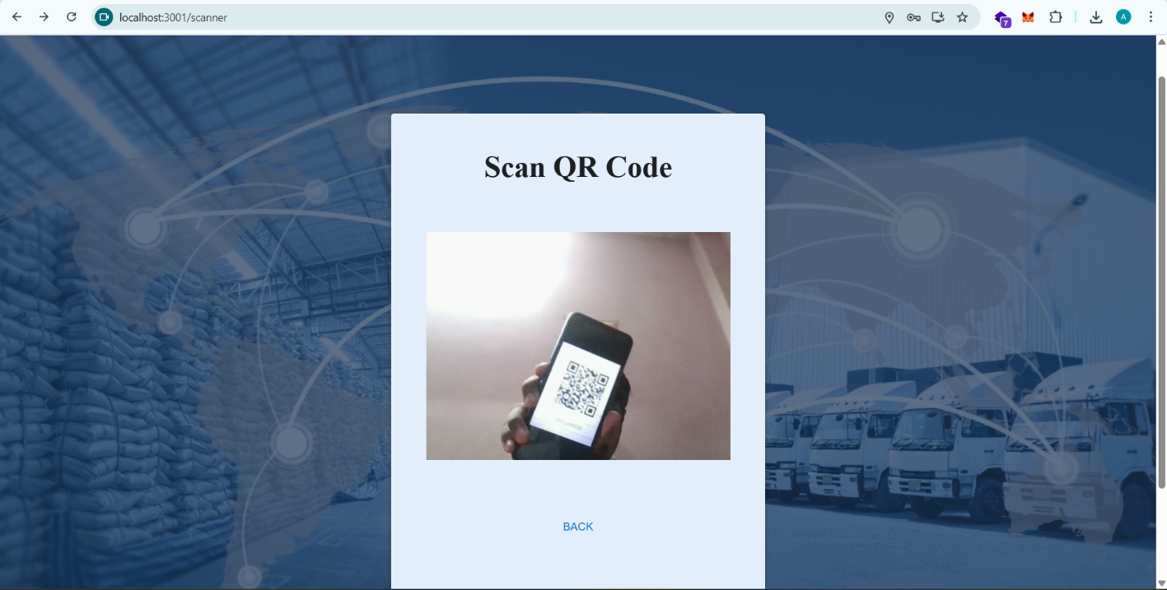
1.6 Retailer needs to Scan QR Code To get the updated Product Details

1.6.1 Retailer can update the sells details of product

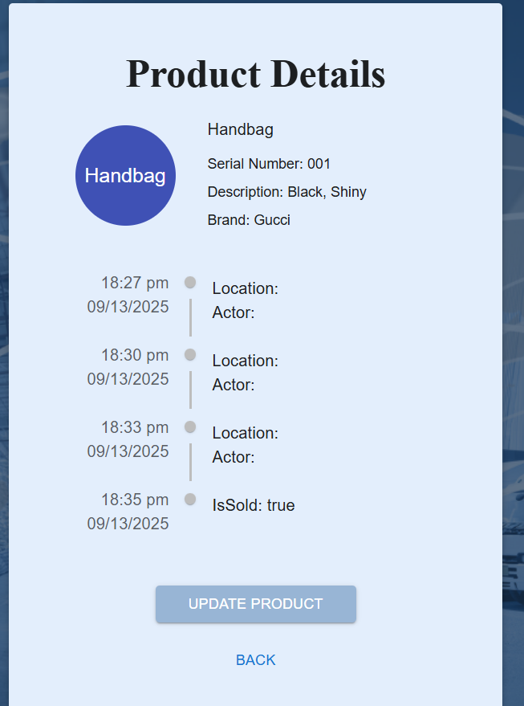
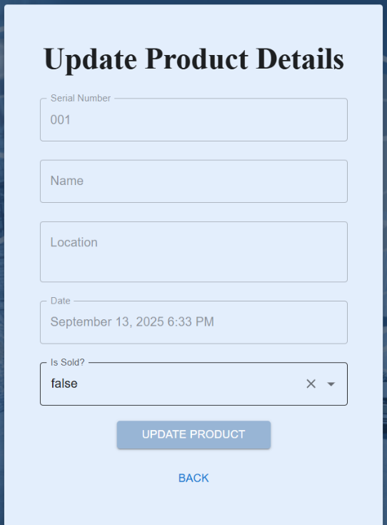

1.6.2 Transactions Details
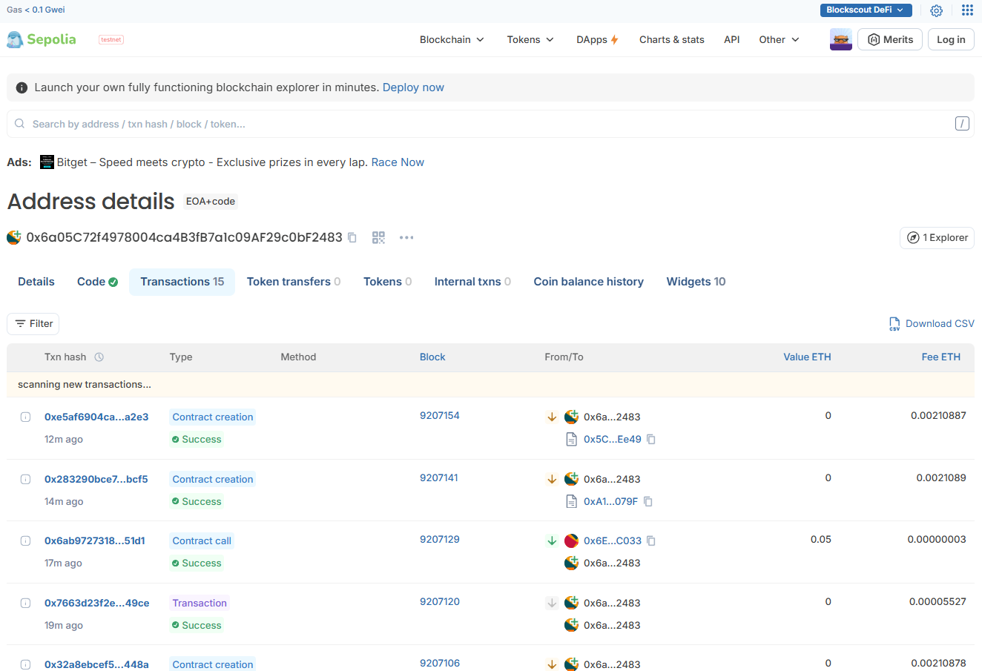

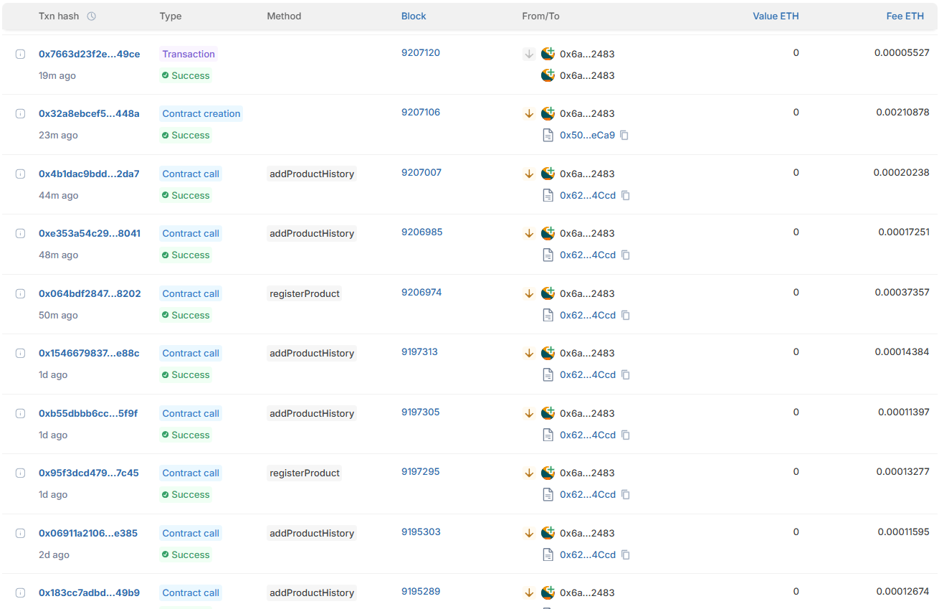

Conclusion:

A QR → blockchain provenance system provides a practical, auditable, and decentralized approach to detect and prevent fake products. By combining off-chain media storage, on-chain anchoring, role-based updates, and wallet-signed transactions, the system creates a verifiable chain of custody from manufacture to sale. For production readiness, address gas-cost strategies, privacy safeguards, and user-friendly wallet flows so that verification becomes frictionless and widely adoptable.
Additionally, this blockchain-powered product verification system fosters trust and transparency across the entire supply chain. Consumers gain confidence by verifying product authenticity themselves, while businesses can protect their brand value and reduce losses due to counterfeiting. Regulatory authorities can also leverage the immutable audit trail for compliance and investigation purposes. By integrating QR-based verification with blockchain, the solution not only combats counterfeit goods but also enhances accountability, efficiency, and collaboration among all stakeholders.

